**Final Case Study – Sudiksha Kamath**

GitHub URL: [sudikshakamath (github.com)](https://github.com/sudikshakamath)

GitHub Repository: [sudikshakamath/shell_case_study (github.com)](https://github.com/sudikshakamath/shell_case_study/tree/main)

Bug Report: [Book1.xlsx](https://my.shell.com/:x:/r/personal/mayank_malhotra_shell_com/Documents/Book1.xlsx?d=w21552e2f51884528b8b4626c9b9878ce&csf=1&web=1&e=IIzPTl)

1. Creation of Virtual Machine:

1. User Stories:

1. TestCases:

**Test#001: Scenario: Successful login with valid credentials**

Given I am on the OrangeHRM login page

When I enter "Admin" as the username

And I enter "admin123" as the password

And I click on the "Login" button

Then I should be redirected to the OrangeHRM dashboard

And I should see the welcome message on the dashboard

**Test#002: Scenario: Unsuccessful login with invalid password**

Given I am on the OrangeHRM login page

When I enter "Admin" as the username

And I enter "wrongPassword" as the password

And I click on the "Login" button

Then I should see an error message "Invalid credentials"

And I should remain on the login page

**Test#003: Scenario: Unsuccessful login with empty username**

Given I am on the OrangeHRM login page

When I leave the username field blank

And I enter "admin123" as the password

And I click on the "Login" button

Then I should see an error message "Username cannot be empty"

And I should remain on the login page

**Test#004: Scenario: Unsuccessful login with empty password**

Given I am on the OrangeHRM login page

When I enter "Admin" as the username

And I leave the password field blank

And I click on the "Login" button

Then I should see an error message "Password cannot be empty"

And I should remain on the login page

**Test#005: Scenario: Clicking "Forgot Your Password" redirects to forgot password screen**

Given I am on the OrangeHRM login page

When I click on the "Forgot your password?" link

Then I should be redirected to the OrangeHRM password reset page

And I should see a form to enter the username or email for password recovery

**Test#006: Scenario: View all claims**

Given I am logged into the system as an admin

When I navigate to the "Claims" section

And I click on "Employee Claims"

Then I should see a list of all claims

**Test#007: Scenario: View claim details**

Given I am logged into the system as an admin

And a list of claims is available

When I click on a specific employee claim

Then I should see the detailed information of the selected claim

**Test#008: Scenario: Assign claim to an employee**

Given I am logged into the system as an admin

And a list of unassigned claims is available

When I select an unassigned claim

And I click on "Assign Claim"

And I select an employee from the list

And I click "Assign"

Then the claim should be assigned to the selected employee

And the status should be updated accordingly

**Test#009: Scenario: Filter claims by status**

Given I am logged into the system as an admin

And a list of claims is available

When I select a status filter "Pending"

Then I should see only the claims with the status "Pending"

**Test#010: Scenario: Search claims by employee name**

Given I am logged into the system as an admin

And a list of claims is available

When I enter an employee name in the search bar

And I click on the search icon

Then I should see the claims related to the entered employee name

**Test#011: Scenario: Search claims by reference ID**

Given I am logged into the system as an admin

And a list of claims is available

When I enter a reference ID in the search bar

And I click on the search icon

Then I should see the claims related to the entered reference ID

**Test#012: Scenario: Search claims by date range**

Given I am logged into the system as an admin

And a list of claims is available

When I select the "From Date" and "To Date" fields

And I enter the desired date range

And I click on the search icon

Then I should see the claims within the specified date range

**Test#013: Scenario: Search claims by event name**

Given I am logged into the system as an admin

And a list of claims is available

When I enter an event name in the search bar

And I click on the search icon

Then I should see the claims related to the entered event name

**Test#014:** Scenario: HR Manager views a claim’s detail

Given the HR Manager is logged into the system

And the HR Manager navigates to the claims section

When the HR Manager views the list of all pending claims

And the HR Manager selects a claim with an amount of 0 Rs

Then the system should display an error message indicating that the claim amount must be greater than 0 Rs

And the claim should be flagged for review or correction

**Test#015: Scenario: Accessing the My Info tab**

Given the user is logged in to the website

When the user navigates to the "My Info" tab

Then the dashboard should display personal details, contact details, emergency contact, jobs, salary, and other information related to the user in the form of a vertical dashboard

**Test#016: Scenario: Viewing Personal Detail**

Given the user is on the "My Info" tab on the website

When the user selects the "Personal Details" tab

Then the personal details form should display the user's current personal information as prefilled fields on the form

**Test#017: Scenario: Updating Personal Details**

Given the user is on the "Personal Details" form in the My Info section

When the user updates the personal information with previously filled data

And submits the form

Then the updated personal information should be saved successfully

And a confirmation message should be displayed

And the same should be reflected across the system

**Test#018: Scenario: Viewing Contact Details**

Given the user is on the "My Info" tab

When the user selects the "Contact Details" tab

Then the contact details form should display the user's current contact information

**Test#019: Scenario: Updating Contact Details**

Given the user is on the "Contact Details" form

When the user updates the contact information with valid data

And submits the form

Then the updated contact information should be saved successfully

And a confirmation message should be displayed

**Test#020: Scenario: Filling the Contact Details form**

Given the user is on the "Contact Details" tab

When the user fills the fields such as contact number

Then the form should accept 10 digit numeric value only

**Test#021: Scenario: Filling the personal details form**

Given the user is on the "Personal Details" tab

When the user fills the fields such as Name, Driver License, Employee ID etc

Then the form should accept valid input for each accordingly

**Test#022: Scenario: Admin successfully applies for leave**

Given the admin user navigates to leave section from the side-menu navbar

When the admin navigates to the 'Apply' tab

And selects a leave type, start date, end date and enters a reason

And clicks on the 'Apply' button

Then the leave request should be successfully recorded in the system

And the leave should appear under the 'My Leaves' tab

**Test#023: Scenario: Admin views leave history with filtering options**

Given the admin user navigates to leave section from the side-menu navbar

When the admin navigates to the 'My leaves' tab

And applies filters by date range, leave status, and leave type

Then the filtered leave history should be displayed correctly

**Test#024: Scenario: Admin generates, and exports leave reports**

Given the admin user navigates to leave section from the side-menu navbar

When the admin navigates to the 'Reports' tab

And generates a report based on leave type, leave status, department or employee

And exports the report as a PDF

Then the report should be generated correctly and available for download as a PDF

**Test#025: Scenario: Admin views and filters leave reports**

Given the admin user navigates to leave section from the side-menu navbar

When the admin navigates to the 'Leave list' tab

And sorts the leave requests by status, leave type, employee name or sub-unit

Then the leave requests should be displayed according to the selected filters and sorting options

**Test#026: Scenario: Admin attempts to apply leave for past dates**

Given the admin user navigates to leave section from the side-menu navbar

When the Admin navigates to the "Apply" tab

And selects a past date for leave

Then an error message should be displayed

And the leave request should not be submitted

**Test#027: Scenario: Admin views pending leave requests**

Given the admin user navigates to leave section from the side-menu navbar

When the Admin navigates to the "Leave List" tab

And filters by "Pending Approval" status

Then all pending leave requests should be displayed accurately

**Test#028: Scenario: Successfully request a password reset link**

Given the user is on the "forgot password page"

When the user enters a registered email address "[user@example.com](mailto:user@example.com)"

And user clicks the submit button

Then the system should send a password reset link to mail address and the system should display confirmation message password reset link sent

**Test#030: Scenario: Request password reset with an unregistered email address**

Given the user is on the "Forgot Password" page

When the user enters an unregistered email address "[unknown@example.com](mailto:unknown@example.com)"

And the user clicks the "Submit" button

Then the system should display an error message "Email address is not registered."

**Test#031: Scenario: Successfully reset password using the reset link**

Given the user has received a password reset link at "[user@example.com](mailto:user@example.com)"

And the user clicks the password reset link

When the user enters a new password "NewPassword123" and confirms it

And the user clicks the "Submit" button

Then the system should display a confirmation message "Your password has been successfully reset."

And the user should be able to log in with the new password

**Test#032: Scenario: Reset password with mismatched confirmation**

Given the user has received a password reset link at "[user@example.com](mailto:user@example.com)"

And the user clicks the password reset link

When the user enters a new password "NewPassword123" and confirms it with "DifferentPassword123"

And the user clicks the "Submit" button

Then the system should display an error message "Passwords do not match."

**TestCase#033: Scenario: In Contact details, email should be verified**

Given the user is on My Info Tab, in contact details,

When the user attempts to enter email,

Then the email address validity should be checked.

1. Bug Report:

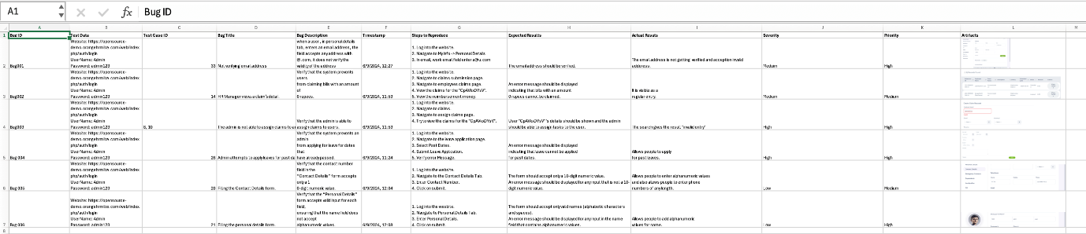

1. Coding Standards:

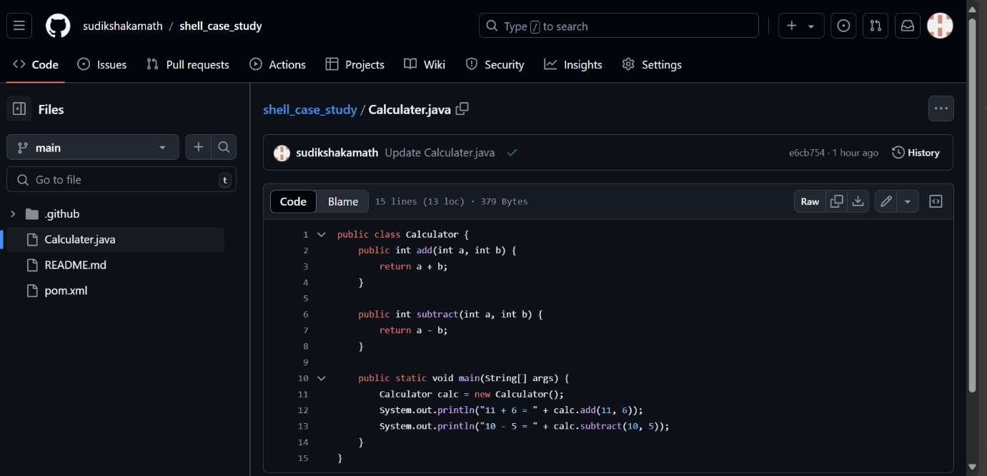

1. GitHub repository:

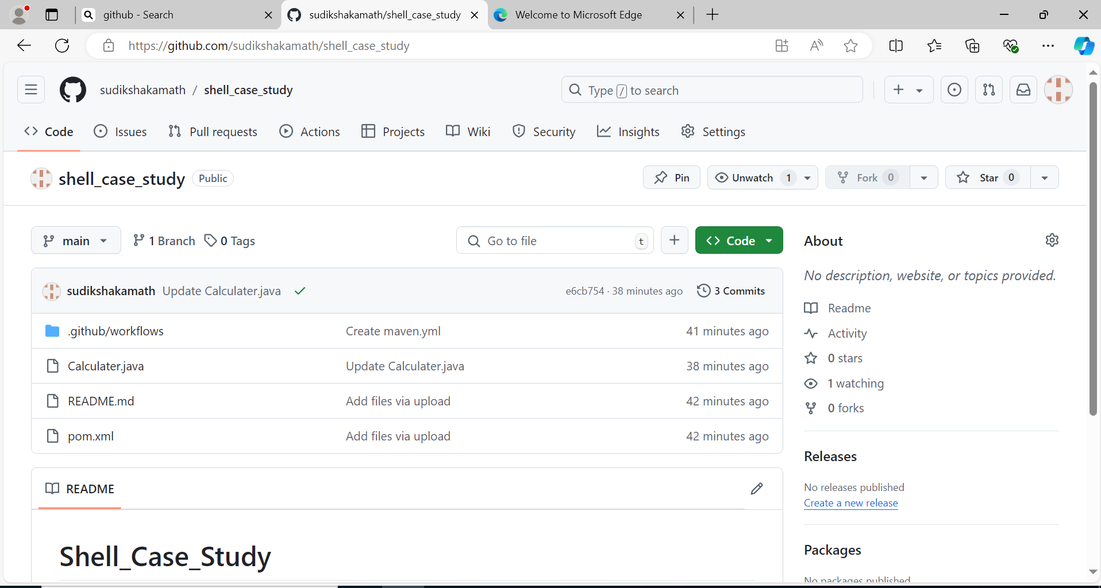

1. GitHub actions or CI/CD Pipeline:

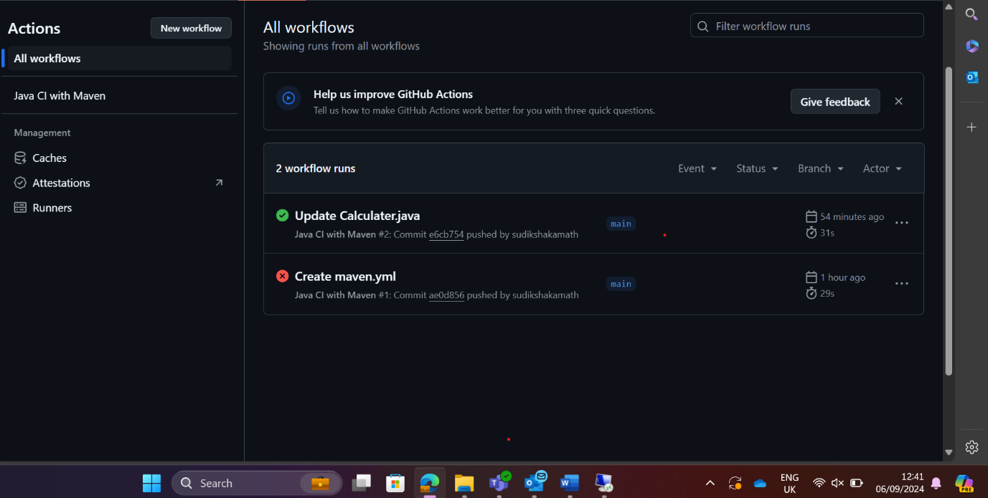

1. Requirement Traceability Matrix:



